**Customer Table**

**PK(CID)**

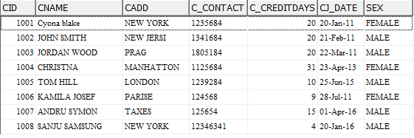

**Vendors Table**

**PK(VID)**

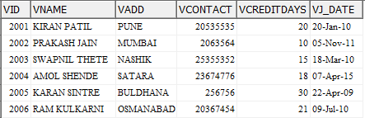

**Employee Table**

**PK(EID)**

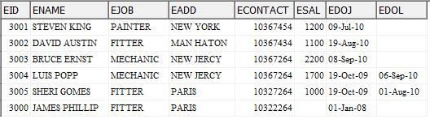

**Sparepart Table**

**PK(SPID)**

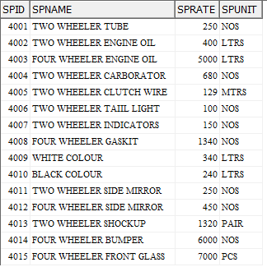

**Purchase Table**

**PK(PID),FK(VID),FK(SPID),FK(eid or RCV_eid)**

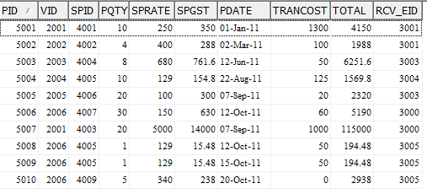

**SER_DET Table**

**PK(SID),FK(cid), FK(EID) ,FK(SPID)**

